# CS 340 README Template

*Use this template to complete your README file. When completing the template, keep the headings as they are so that your document has a clear organization. Remove the italicized prompt text after you have completed each section for a polished final document.*

## About the Project/Project Title

*This program’s purpose was to provide the groundwork for Grazioso Salvare to allow them to better identify dogs that are good candidates for search-and-rescue training through filtering through the animal shelters database to find dogs that fit their preferred traits.*

## Motivation

*This project was created to satisfy those needs of Grazioso Salvare. Having the ability to better search the databases that are provided substantially increases their abilities to have access to more dogs to train, which allows them to better have the resources for when a search and rescue is needed.*

## Getting Started

*To begin with the program:*

1. *Download and install MongoDB and python*
2. *User will need to create an account or have an admin create one.*

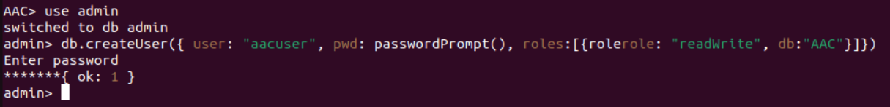

1. *Enter MongoDB and import the csv file.*



*This is an example of importing the file into MongoDB, ${MONGO_USER} and ${MONGO_PASS} would be adjusted to the users own information, same as the port and host. The code as provided should adjust to the default values present but for limiting access, further steps would need to be taken.*

1. *User can then run the program as shown in this description.*

## Installation

*A current version of jupyter notebook, python and MongoDB would be needed to properly access and run the program.*

## Usage

*Use this space to show useful examples of how your project works and how it can be used. Be sure to include examples of your code, tests, and screenshots.*

### Code Example

### 

The user will be greeted with a title and the logo *of Grazioso Salvare.*

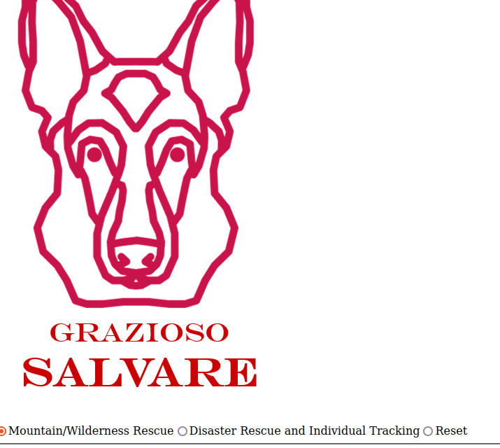

Scrolling down more gives the user the option to select which type of search filter they would like to apply. There is also a water option, but I was unable to get it to fit on the same screenshot.

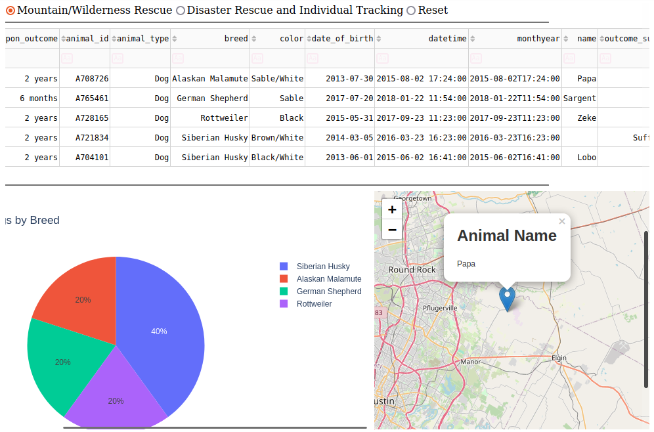

Once selecting a filter, the data will repopulate with results from the filter. Providing a pie chart separating the breeds returned as well as the user being able to select animals on the table to place a marker on the map of their location.

## Contact

Your name: Justin Farquhar